ITA14 - ETHICAL HACKING EX – 1
Execute and display the results for the following commands in Kali Linux Operating System: rm command, users command, and tree command.

Aim:
To Execute and display the results for the following commands in Kali Linux Operating System: rm command, users command, tree command.
Procedure
• Open Kali Linux
• Open Terminal
rm command
- touch sample1.txt -- press Enter
- ls -- press Enter
- touch sample2.txt -- press Enter
- ls -- press Enter
- touch sample3.txt -- press Enter
- ls -- press Enter
- touch sample4.txt -- press Enter
- ls -- press Enter
- touch sample5.txt -- press Enter
- ls -- press Enter
- rm sample5.txt -- press Enter
tree command
- tree -- press Enter
- mkdir EH -- press Enter
- cd EH -- press Enter
- touch file1.txt -- press Enter
- tree -- press Enter
- mkdir Unit1 -- press Enter
- cd Unit1 -- press Enter
- touch topic1.txt -- press Enter
- touch topic2.txt -- press Enter
- touch topic3.txt -- press Enter
- touch topic4.txt -- press Enter
- touch topic5.txt -- press Enter
- tree -- press Enter

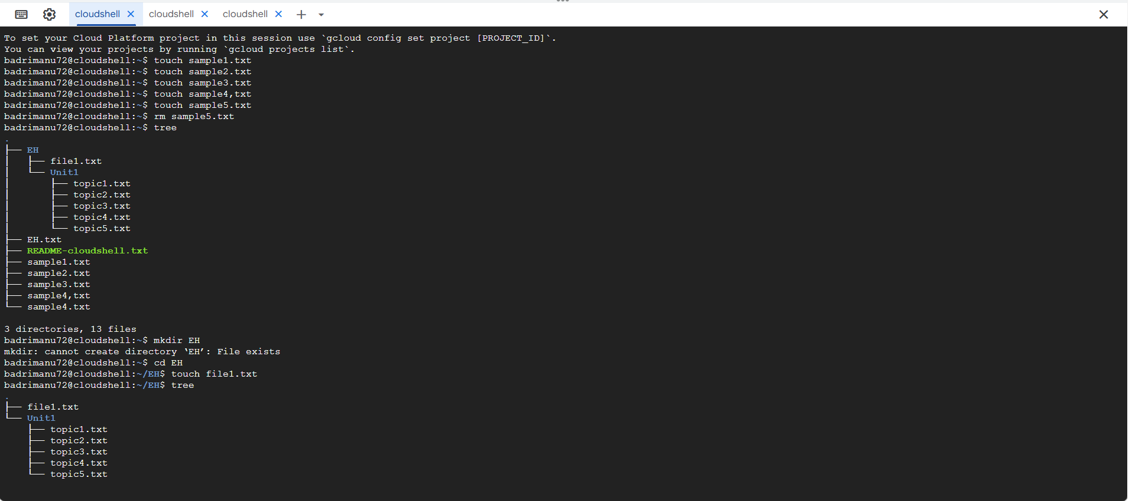
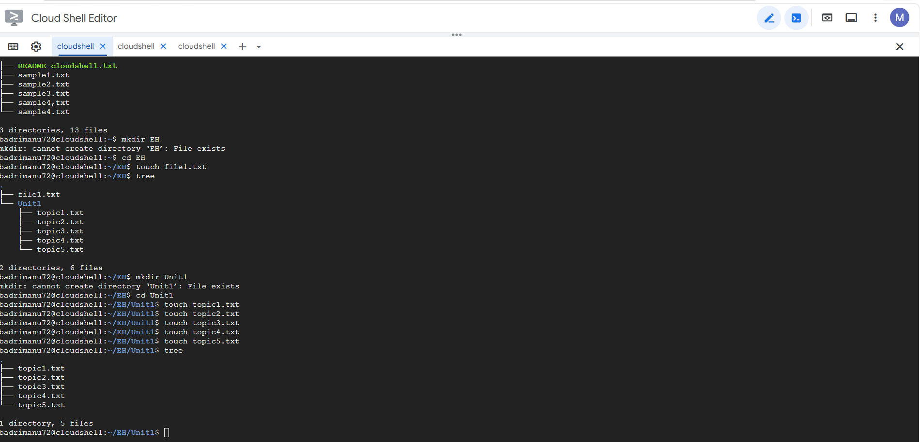

Result
Thus, the rm, users, and tree commands were successfully executed in Kali Linux, and their results were displayed.

